

# Week Seven Lab Work

# Networking Infrastructure / International Development Conditions

# Network Calculation Tasks

Perform an investigation and establish the current network infrastructure supported in Ireland.

We have discussed previously how Ireland is a Greenhouse and Hub for a substantial amount of Cloud Providers, this in turn would not be possible without certain pre-requisites.

During your investigation of Ireland Network infrastructure additionally establish some of the reasonings behind the popularity of Ireland for Cloud Service Providers and major international companies establishing a Head Quarters on the island of Ireland.

1. **Explain the current Irish Telecommunications Network infrastructure, the following points can be used to structure your study**
   1. Historical Context
   2. Recent Developments – Articles / Papers / News Items
   3. Current Coverage – Is Fibre available every where
   4. Current Investments
   5. Ownerships and stakeholders
   6. Previous / Historical Complications or Issues
   7. Main Providers of telecommunication services in Ireland e.g Vodafone Broadband
2. **Give reasoning and your own understanding as to why Ireland is a popular Hub for international companies to “Setup” here in Ireland.** 
   1. Provide 3-4 points and a description of your reasoning, typical subcategories include taxation and Populus.
3. Using the below illustration establish the following

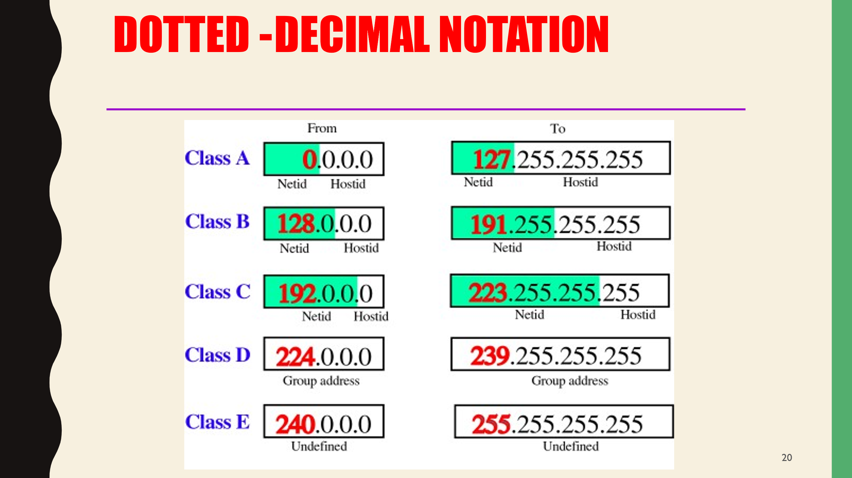

* **Find the class of the following IP addresses.**
* **208.34.54.12**
* **238.34.2.1**
* **114.34.2.8**
* **129.14.6.8**

Upon successfully Identification of the classes of each address above establish the NetID and HostID of the above IP “InternetProtocals” Addresses.

1. Establish your current network speed using an online network speed identifier.
   1. Examples of such services:
      1. <https://www.speedtest.net/>
      2. <https://broadbandspeedtest.ie/>
      3. <https://www.eir.ie/support/broadbandspeedtest/>

The above examples give you the ability to change your destination tester, typically Dublin, change this variable and identify any changes in the network speed. Attempt to burden the network with multiple tabs or a large download and identify any changes in network speed.

Additionally, if you are connected through ethernet change to wifi connection and identify if any a degradation in speed achieved. Example Below.

How does the speed results differ based upon e.g the destination being Pinged / the Medium being used / the burden on the network / the device being used ?

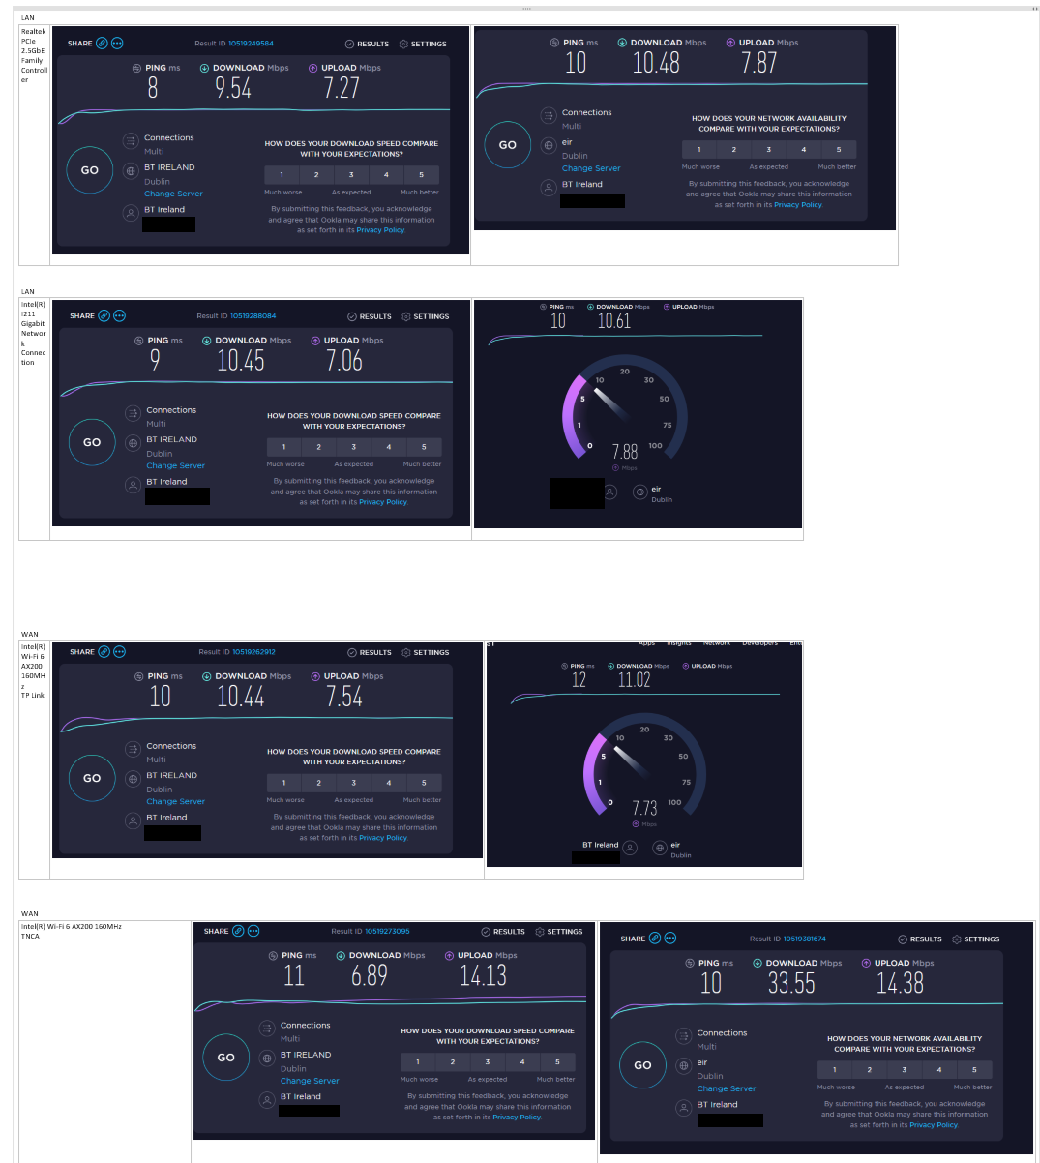

Figure 1Tests Performed using Ethernet & Wifi also different Connections and Connection Hardwares

Compare your results to the above. Ensure to hide your ip if providing screenshots as seen above.

If you need to provide screenshots , no only for CAOSN but for other modules , I recommend the snipit tool from windows and then using Paint.Net a free useful tool. <https://www.getpaint.net/>